**HORMISDALLEN SCHOOL - KYEBANDO**

**PRE- PLE SET 7 EXAMINATIONS, 2023**

**PRIMARY SEVEN SOCIAL STUDIES**

**Duration: 2 Hours 15 Minutes**

**NAME: ______________________________________________ STREAM: _________**

INDEX NO.

EMIS NO.

**SECTION A**

1. Apart from a title and a scale state any other thing that a good map should have.

__________________________________________________________________________

1. What type of climate is hot and wet throughout the year? __________________________________________________________________________
2. Why is it important for Ugandans to pay taxes?

__________________________________________________________________________

1. In which way does weather affect the type of cloth people wear?

__________________________________________________________________________

1. Give one reason why television is not widely used in rural areas in Uganda.

__________________________________________________________________________

1. Which countries qualify to be members of common wealth?

__________________________________________________________________________

1. Under what circumstances is the Uganda flag flown at half-mast?

__________________________________________________________________________

1. Why is it dangerous for a country to depend on one produce for its international trade?

__________________________________________________________________________

1. In which way did the coming of Arabs affect the way of life in East Africa?

__________________________________________________________________________

1. Why is rice mostly grown in swampy areas?

__________________________________________________________________________

1. Which ministry is responsible for population census in Uganda?

__________________________________________________________________________

1. Mention any one farming system where farmers get double income.

__________________________________________________________________________

1. What is the importance of the Uganda National Examinations Board in the Education system of Uganda?

__________________________________________________________________________

1. State any one political challenge facing most African countries.

__________________________________________________________________________

1. Name the British official that turned Makerere College into a University.

__________________________________________________________________________

1. Name the main tributary of River Niger

__________________________________________________________________________

1. How do people benefit from making crafts?

__________________________________________________________________________

1. What does the Uganda Kob on the Coat of Arms represent?

__________________________________________________________________________

1. Give one reason why people use a zebra crossing on a busy road.

__________________________________________________________________________

1. In which way was the struggle for independence in Uganda different from that of Kenya?

__________________________________________________________________________

1. State one reason why Liberia was not colonized.

__________________________________________________________________________

1. Which imaginary line determines time - zones?

__________________________________________________________________________

1. Name one Bantu tribe in Uganda.

__________________________________________________________________________

1. What is the duty of the National Identification and Registration Authority in Uganda?

__________________________________________________________________________

1. State what made Ethiopia land locked in 1993?

__________________________________________________________________________

1. How is a charcoal saving stove environmentally friendly?

__________________________________________________________________________

1. How is Lake Katwe important to the people of Uganda?

__________________________________________________________________________

1. Which dam is a reservoir of water for irrigation on Gezira Scheme?

__________________________________________________________________________

1. Why was Tanzania called a mandated territory?

__________________________________________________________________________

1. How do water bodies influence the climate of Uganda?

__________________________________________________________________________

1. Why did **O.A.U** change to African Union in 2002?

__________________________________________________________________________

1. Give one way UNICEF helps children to live a better life.

__________________________________________________________________________

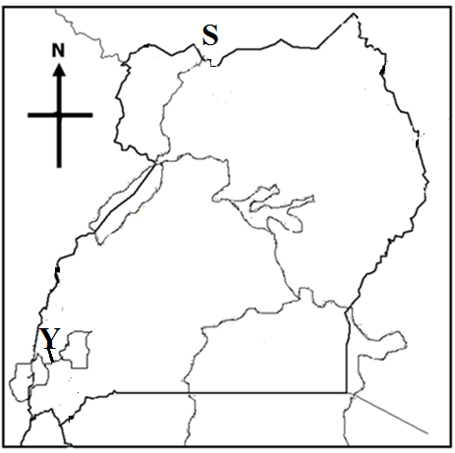**Study the map of Uganda below carefully and use it to answer questions 33 - 35.**

1. Use letter **K** to show Kidepo Valley national park.
2. Name the country marked letter **S**.

________________________________________________________________________________________

1. Name the water channel marked with letter **Y**.

________________________________________________________________________________________

**For each of the questions 36 to 40, answer Either the Christian OR Islamic question, but not both in a number.**

1. **Either:** Mention one person in the Bible whose name was changed by God.

__________________________________________________________________________

**Or:** Mention the title a Muslim woman gets after Hijja.

__________________________________________________________________________

1. **Either:** Name the prophet who foretold the birth of Jesus Christ in a small town called Bethlehem.

__________________________________________________________________________

**Or:** How did Prophet Muhammad show love to his people?

__________________________________________________________________________

1. **Either:** Why did Jesus Christ wash the feet of his disciples?

__________________________________________________________________________

**Or:** Why did Allah give Muhammad the pillars of Islam?

__________________________________________________________________________

1. **Either:** Who was the last prophet according to Christianity?

__________________________________________________________________________

**Or:** Who is believed to be the last prophet according to Islam?

__________________________________________________________________________

1. **Either:** Name the mountain where Moses saw the burning bush.

__________________________________________________________________________

**Or:** Name the mountain where Prophet Musa was the burning bush.

__________________________________________________________________________

**SECTION B.**

1. a) What is rural electrification? _________________________________________________

__________________________________________________________________________

1. Suggest any two reasons why the Uganda government has advocated for rural electrification programme.
2. __________________________________________________________________________
3. __________________________________________________________________________
4. Give any one challenge to rural electrification in Uganda today.

__________________________________________________________________________

1. a) Name the European country that fought in the Maji Maji rebellion.

__________________________________________________________________________

1. Suggest a reason why Maji-Maji rebellion was called so?

__________________________________________________________________________

1. Write any two causes of Maji-Maji rebellion.
2. __________________________________________________________________________
3. __________________________________________________________________________
4. 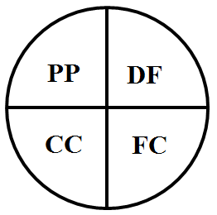**Junju uses his piece of land as shown in the diagram below. Use it to answer the questions that follow.**

**KEY.**

PP - Planting grass.

CC - Growing cash crop.

FC - Growing food crop.

DF - Dairy farm.

1. What type of farming does Mr. Jungu practice?

__________________________________________________________________________

1. Give the reason to support your answer in question (a) above.

__________________________________________________________________________

1. State the reason why Mr. Jungu plants grass?

__________________________________________________________________________

1. How would you advise Mr. Jungu to utilize his animals to improve on his crops?

__________________________________________________________________________

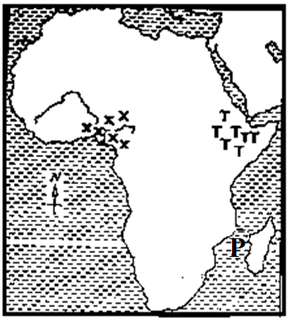**Study the sketch map of Africa and answer the questions that follow.**

1. a) Name the water way marked with letter **P** on the map.

__________________________________________________________________________

1. Mention one economic activity carried out in area marked **X**.

__________________________________________________________________________

1. Name one land locked country found in the region marked **TTT**.

__________________________________________________________________________

1. Why is the above map called a sketch map?

__________________________________________________________________________

1. a) What role did Chancellor Otto Von Bismark play towards the colonization of Africa?

__________________________________________________________________________

1. State one way Europeans got colonies in Africa.

__________________________________________________________________________

1. State two reasons why African resistance to colonial rule was easily defeated by colonialists.
2. __________________________________________________________________________
3. __________________________________________________________________________
4. a) What is smuggling?

__________________________________________________________________________

1. Which body in Uganda is responsible for curbing smuggling?

__________________________________________________________________________

1. Give one reason why smuggling is dangerous to the economy of the country.

__________________________________________________________________________

1. Name the major source of government revenue in Uganda.

__________________________________________________________________________

1. **Match the trading companies with their founders.**

**List A List B**

1. Cotton Used to make cooking oil.
2. Sugarcane Used to make insecticides.
3. Oil palm Used to make clothes.
4. Pyrethrum Used to make sugar.
5. Cotton: ______________________________________________________________
6. Sugarcane: ______________________________________________________________
7. Oil palm: ______________________________________________________________
8. Pyrethrum: ______________________________________________________________
9. a) Give the importance of vegetation to wild animals.

­__________________________________________________________________________

1. State any two factors that influence vegetation distribution.
2. __________________________________________________________________________
3. __________________________________________________________________________
4. Mention the vegetation zone where most game parks are found.

__________________________________________________________________________

1. a) Why didn't Kabaka Mwanga represent Buganda during the signing of 1900 Buganda Agreement?

__________________________________________________________________________

1. Give any two terms of 1900 Buganda agreement.
2. __________________________________________________________________________
3. __________________________________________________________________________
4. How did the 1900 Buganda agreement reduce the powers of the Kabaka?

__________________________________________________________________________

1. a) State the meaning of the term optimum population.

__________________________________________________________________________

1. The area Nyabuhikye Sub-county is 160km2 and its population is 320,000 people. Find the population density of Nyabuhikye Sub-county.

1. Give any two dangers of a dense population to a country.
2. __________________________________________________________________________
3. __________________________________________________________________________

**For questions 51-54, answer Either Christian Or Islamic not both in a number.**

1. **Either: "Love the Lord your God with all your heart, with all soul and with all your mind". (Matthew 22:37)**
2. Who said the above words?

__________________________________________________________________________

1. To which group of people were the above words said?

__________________________________________________________________________

1. State any two lessons we learn from the above quotation.
2. __________________________________________________________________________
3. __________________________________________________________________________

**Or:** **"There is no god except Allah. Death really causes pain. Oh God! Cover me with**

**your forgiveness and mercy"**.

1. Who said the above words?

__________________________________________________________________________

1. Who was the first wife of the person you have named in **(a)** above?

__________________________________________________________________________

1. In which two ways did the above mentioned wife help Prophet Mohammad in his life?
2. __________________________________________________________________________
3. __________________________________________________________________________
4. **Either:**
5. What is authority?

__________________________________________________________________________

1. Name any two types of authority.
2. ___________________________________
3. ___________________________________
4. State the reason why authority is used at school.

__________________________________________________________________________

**Or:**

1. What is authority?

__________________________________________________________________________

1. Name any two types of authority.
2. ___________________________________
3. ___________________________________
4. State the reason why authority is used at school.

__________________________________________________________________________

1. **Either:**
2. Apart from Islam and Christianity, mention any other two world religions.
3. __________________________________________________________________________
4. __________________________________________________________________________
5. Give one way how people can respect other people's religions.

__________________________________________________________________________

1. Give one reason why a P.7 pupil should respect other people's religions.

__________________________________________________________________________

**Or:**

1. Apart from Islam and Christianity, mention any other two world religions.
2. __________________________________________________________________________
3. __________________________________________________________________________
4. Give one way how Muslims can show respect to other peoples' religions.

__________________________________________________________________________

1. Why should Muslims respect other people's religions?

__________________________________________________________________________

1. **Either:**
2. Name the river where Jesus Christ was baptized.

__________________________________________________________________________

1. State two strange things that happened during the baptism of Jesus Christ.
2. __________________________________________________________________________
3. __________________________________________________________________________
4. What did the dove represent during the baptism of Jesus?

__________________________________________________________________________

**Or:**

1. Name the symbol of purity in Islam.

__________________________________________________________________________

1. State any one reason why Muslims perform that act above.

__________________________________________________________________________

1. What happens to a Muslim believer after performing the symbol of purity mentioned in (a) above?

__________________________________________________________________________

1. State any one reason why it is important for every male person in Uganda to perform the act of purity?

__________________________________________________________________________

1. **For both Candidates:**
2. State any two similarities in practice between Christianity and Islamic religions.
3. __________________________________________________________________________
4. __________________________________________________________________________
5. State any two differences in practice between Christianity and Islamic religion.
6. __________________________________________________________________________
7. __________________________________________________________________________

**\*\*\*\*Good luck\*\*\*\***